Class: One **First Terminal Examination -2082** Subject : Science FM:25

Name: Roll No:

**Q.no.1) Fill in the blanks. [5]**

(**vitamins, dung ,salad, firewood, shampoo)**

a) Vegetables are the good source of ___________.

b) Firecake is made from cow or buffalo _________.

c) We can eat _________ without cooking.

d) We use _________ to cook food.

e) We wash our hair with soap and _________.

**Q.no.2) Write ‘T’ for true and ‘F’ for false sentences.[4]**

a) Chocolates and Pastries are good for our teeth. _______

b) We should wash our face with soap and cold water. _______

c) We should clean our nose with our fingers.________

d) I use hanky to wipe my nose. _______

**Q.no.3) Name the following. [6]**

a) Name any two uses of fire.

i)_________ ii)__________

b) Name any two fruits.

i)_________ ii)__________

c) Name any two food that you like but harms your teeth and gums.

i)_________ ii)__________

**Q.no.4) Match the following. [4]**

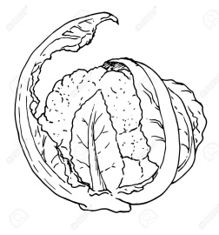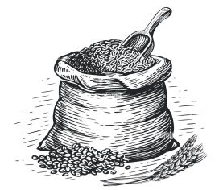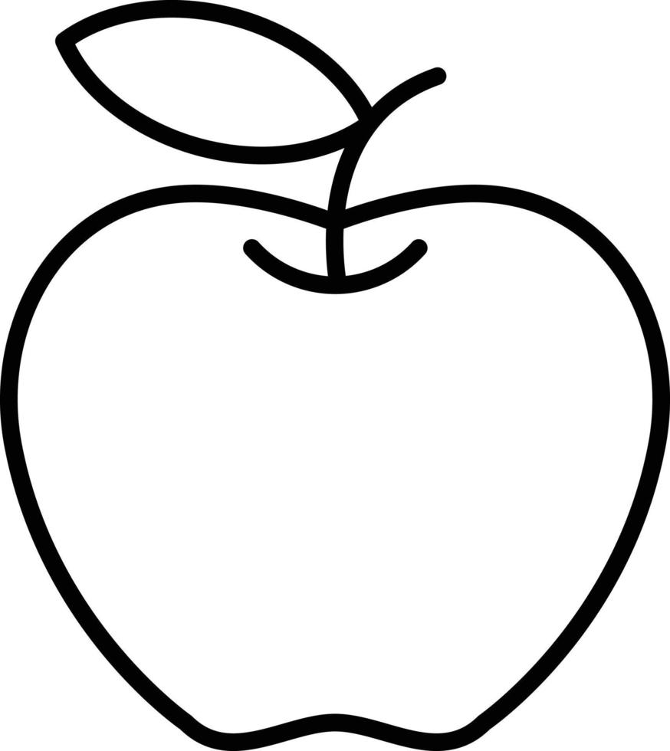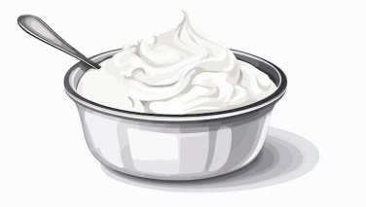

a) Food grain

b) Vegetable

c) Curd

d) Fruit

**Q.no.5) Answer the following questions. [6]**

a) Where was Sanduk Ruit born?

b) When should you take a shower?

c) What makes our food dirty?

**The End**